MOCK TRIALS room /1 st floor (Group 1) & SEMINAR room/7 th floor (Group 2)

&

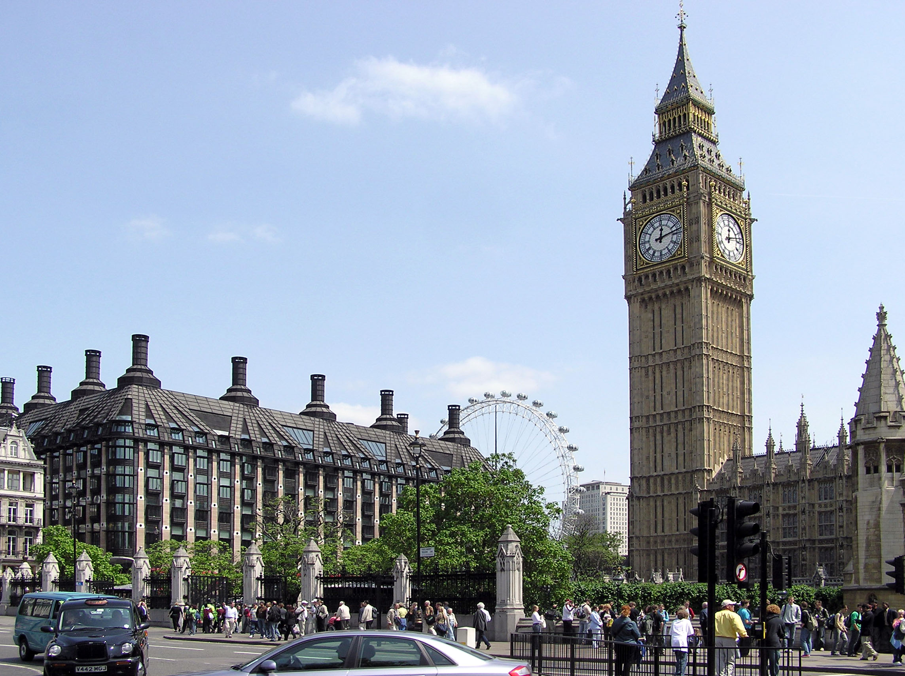

Training Seminar

BUCHAREST, SEPTEMBER 25th – 29th 2017

Legal English